Projectile Motion Simulation Using Python
Name – Ravi Prakash
Grade – XII

Abstract
Projectile motion refers to the movement of an object that is launched into the air, following a curved path under the influence of gravity alone. This motion has two completely independent, simultaneous parts:
Horizontal Motion (x-axis): Moves at a constant velocity (v_x) because no horizontal forces act on the object, ignoring air resistance.
Vertical Motion (y-axis): Experiences a constant downward acceleration due to gravity (g = 9.8 \text{ m/s}^2). This causes the object to slow down as it rises and speed up as it falls.
Together, these perpendicular vector components create a unique, symmetrical parabolic path determined entirely by the initial launch speed and angle.
Introduction
What is Projectile Motion? Projectile motion is a basic concept in physics related to kinematics. It refers to an object (the projectile) moving after it is thrown through the air. In reality after an initial launch, the object would only experience the pull of gravity and (in the real world) air resistance. The wonders of projectile motion can be explained by treating it as a two-part, simultaneous journey: Horizontal Motion: The projectile travels horizontally with a constant speed because there are no forces acting on the horizontal part of the projectile’s motion. Vertical Motion: The projectile travels in exactly the same way as an object falling freely in space. It has gravity to oppose its upward motion (as it goes up, the object slows down), then as it falls, it has gravity to pull it down (as it falls, the object speeds up). Since horizontal motion is constant and vertical motion changes, the projectile follows a shape called a parabola. A common parabola is what many consider to be the classic projectile motion path. Practical Application Many real-life scenarios involve projectile motion and are evident all around us everyday: Cricket: A boundary fielder making a long, high throw straight back to the wicket keeper's hand. Football: A goalkeeper making a big goal kick with the ball soaring through the air and landing past the halfway line. Basketball: An athlete attempting a three pointer, perfectly arc-ing the ball through the hoop. Every day activities such as a stream of water coming out of a hose, arrows shot from a bow, even the trajectory of a stunt car jumping over a ramp can also be considered projectile motion. What makes projectile motion important in physics? It’s not just about tracking sport balls – projectile motion is one of the corner stones of classical physics for the following reasons: It demonstrates Independence of Motion- As Galileo originally theorized, any force acting on the vertical component of projectile motion is completely irrelevant to the horizontal component and vice versa. It allows one to understand Vectors- Projectile motion provides the perfect, practical introduction into vector decomposition, that is, how to separate an angled velocity into a horizontal and vertical component. It provides a basis for accurate calculations- All calculations of the paths rockets will take to leave Earth, ballistic missiles entering Earth's atmosphere and landing points for re-entry craft are based on the mathematics of projectile motion.
Objective
The fundamental objective of this project is to computationally model and simulate the physics of a launched object. The main aims of this project are:
Modeling projectile motion using Python; The use of programming packages such as NumPy and Matplotlib is to demonstrate the physics equation, and turn it into an animated and interactive computational model.
Computation and plotting of trajectory; to accurately compute the coordinates of the projectile at each step, and plot it, along with the decomposition of horizontal and vertical velocity vectors during the course of time.
Study the effect of gravity; to demonstrate visually the independent movement of horizontal and vertical motions and portray clearly the effect of the constant acceleration due to gravity in the downward direction upon the trajectory of an object during the course of time.
Theory
Projectile Motion Definition
Projectile motion refers to a form of two-dimensional kinematics, which is the description of motion under the effect of a constant gravitational field once an initial velocity is imparted to an object (projectile). From this point forward, the projectile's path is solely governed by the acceleration of gravity and its initial launch parameters and traces a curve in the form of a parabola.
Assumptions
In order to obtain an extremely accurate approximation of the problem under ideal physical conditions, the following assumptions are commonly made:
No Air Resistance
The absence of air currents, fluid resistance, and any other form of aerodynamic drag. Under this condition, the velocity in the horizontal direction remains constant at all points throughout the motion of the projectile.
Constant Gravity
The force of gravity acts downwards and its value remains constant at all points throughout the projectile's flight: g = 9.8 m/s^2. The Earth's curvature and the effect of its rotation are disregarded, which corresponds to the flat earth approximation as is applicable to the distances of flight typically encountered.
Kinematic Equations Breakdown
If a projectile is launched with an initial velocity V o and at an angle theta above the horizontal plane, then the initial velocity is the resultant of the two perpendicular components V x and V y. These may be determined through:
V x = V o cos (theta)
V y = V o sin (theta) – gt
Relevant Mathematical Equations
Time of Flight (T)
The time elapsed from when a projectile is launched to when it falls back to the launch height (y=0):
T= 2 V o sin (theta) g
Maximum Height (H)
The maximum altitude attained by the projectile, which is achieved at the peak of its trajectory where V y is momentarily zero.
H = ( V o^2 sin 2(theta)) 2g
Horizontal Range (R)
The horizontal distance traveled from the launch point to where the projectile lands on a horizontal plane.
R = ( V o^2 sin(2 theta)) g
Methodology
Tools Used
Python: The base language for the program where program logic is developed, and runtime is managed.
NumPy: A library used for array based math that managed multi-point time tracking and trigonometric functions (Sine, Cosine) that define the trajectory of the projectile.
Matplotlib: A plotting library used to layout and animate the visualization. Used the FuncAnimation module to update frames and 'quiver' function to manage vector arrows.
Process Overview
Obtaining Inputs
User input for both the projectile launch velocity (in m/s) and the launch angle (in degrees) is prompted at the command prompt.
Angle Transformation
Because trigonometric functions only work with angles measured in radians within standard computing languages, a conversion from degrees to radians is calculated.
Calculation of Time and Trajectory
The projectile's total flight time is calculated, then it is broken down into 200 equal time steps from the point of launch to the point of landing. Each point is then used to determine the corresponding projectile horizontal and vertical location.
Animation and Event Management
The program is launched with a plot canvas that is arranged with axis limits that depend on the max vertical and horizontal distance traveled, and with basic gridlines. The initial projectile point, its path and the velocity vector arrows are displayed. An animation is initiated which dynamically updates frame-by-frame with calculated points. A canvas listener is attached which, on left click, will pause/unpause the animation, making it interactive.
Results
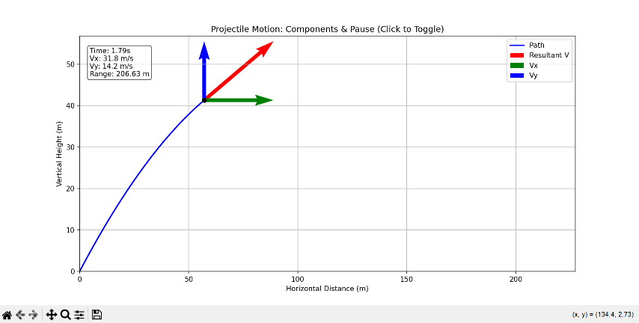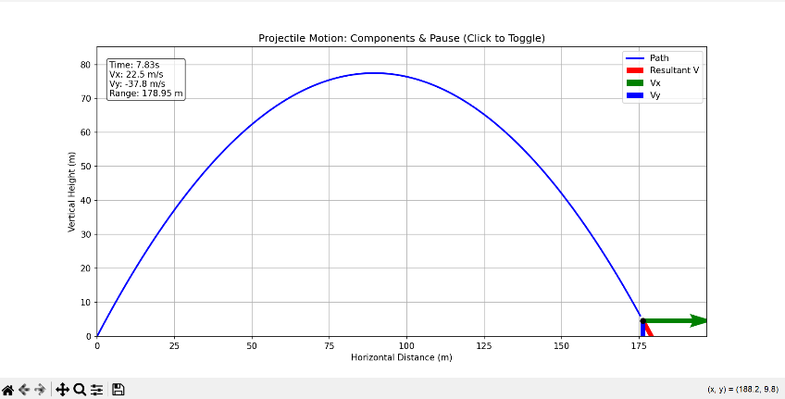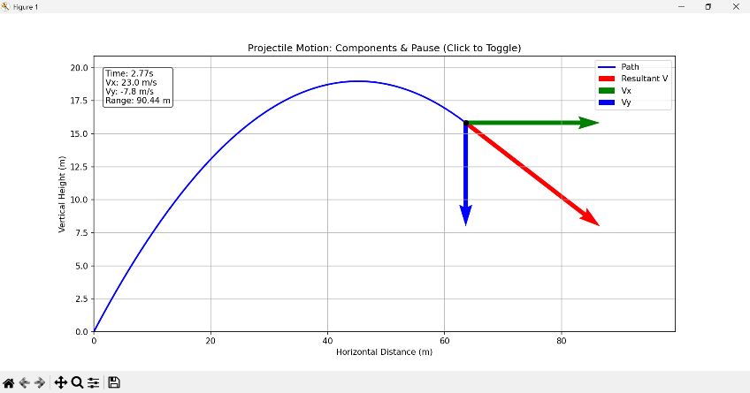
Trajectory Observations
The visual display of the simulation clearly shows a nice, symmetrical parabola making up the projectile's trajectory. This trajectory tells us what the general concept of the flight should be: constant, uninterrupted horizontal movement across a 2-D plane and accelerating vertical motion down a path of constant force of gravity.
The Effect of Launch Angle on Max Height
The display shows how the launch angle has direct effect on how far the projectile goes up. When increasing the launch angle from 0 degrees to 90 degrees, more and more of the launch angle becomes applied to the vertical launch speed, thus making the higher angles fly much farther up the vertical path until 90 degrees, when the highest vertical point will be reached.
The Effect of Launch Angle on Horizontal Range
The horizontal range can be defined as follows:
Maximum Range- The maximum horizontal range occurs at exactly 45 degrees. Here, the velocity is divided so the projectile can maintain horizontal speed for the longest period possible.
Angles lower than 45 degrees will achieve a smaller range due to too much horizontal velocity so that the projectile can not get very far away before hitting the ground. Angles greater than 45 degrees fly too high with not much horizontal velocity so will have smaller range too.
Complementary Angles- If one were to use angles that add up to 90 degrees, such as 30 degrees and 60 degrees, they will fall at the same horizontal point although one will clear a far greater maximum height.
Conclusion
What was learned
I got hands-on practice from this program, how to convert theory physics equations into an interactive real-world computer model. I learned how to take arrays of discrete time, put them into ordered NumPy arrays and then take moving vectors and create both a visual animation, and represent their motion using a vector plot via the quiver tool (part of Matplotlib). I also learned event-driven coding by seeing how a real time input of mouse-click can be used to freeze and unfreeze the live canvas window.
What the simulation proved
This simulation physically, and numerically proves the basic idea behind projectile motion: 2-dimensional motion is independent. The velocity is the same horizontally throughout and is 0 vertically throughout; instead, there is only a constant force in the vertical direction (gravity), and only in the vertical direction. As the path lines of different inputs demonstrate, when observing how they evolve over time with different inputs and launches, the kinematic equations of projectile motion are completely proven by the model as a 45-degree angle is launched at gives both the greatest amount of air time, and is at a velocity sufficient to achieve the maximum horizontal distance.
Physics versus Coding
What this program showed was the power of using computing as a tool to learn and analyze physics laws. Physical phenomena usually represented with static equations with static values calculated on paper are, with coding, shown to be a continuous system that uses many coordinate values to calculate each point along a trajectory in order to have real time display. The use of programming allows us to look at how theoretical equations can represent dynamic systems with variables that can be inputted by the programmer to test hypotheses.

